Direcciones: Look at the picture and say what each person (or group) is doing by conjugating the given verb to the present tense. Then write a 2nd sentence using “ser” to describe each person’s (or group’s) personality.

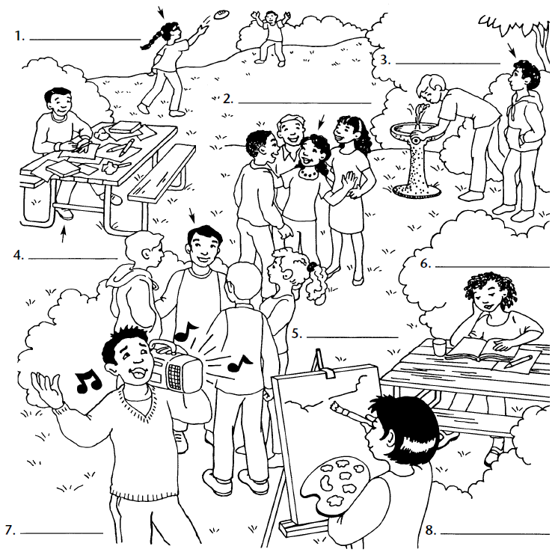
Ramona (Pintar)
Enrique
(Escuchar música y cantar)
Martín
(Terminar la tarea)
Eduardo
(Pasar tiempo
con amigos)
Sofia (Estudiar)
Carlos
Esperar (to wait)
Luisa
(Hablar mucho)
María y Juan
(Practicar deportes)

